Cut and paste all names that begin with S with the correct pictures.
Copy and paste all the other names.

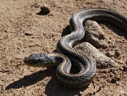 |  | 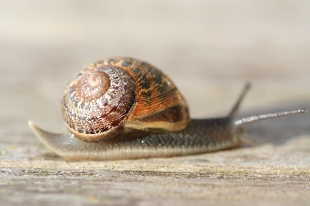
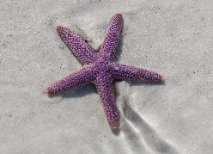 |  | 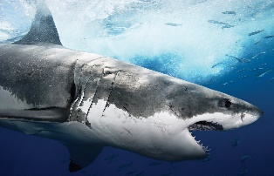
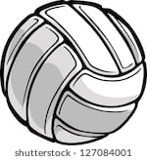

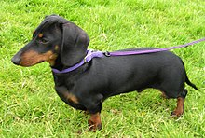 |  | 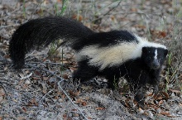
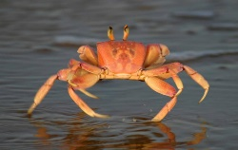 |  | 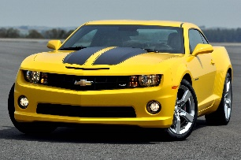
Shark Crab Dog Car Skunk Volleyball
Books Starfish Snake Snail

